Can you hold your own?
Below are a series of quotes held by politicians, leaders, scientists, and celebrities. Without getting too political, we have covered specifically the science involved in each of these statements. We’re not taking sides here, there is no good or evil. Can you refute the statements below utilizing the knowledge you’ve picked up along the course? Bonus points: find a legitimate source for your data/argument.
- 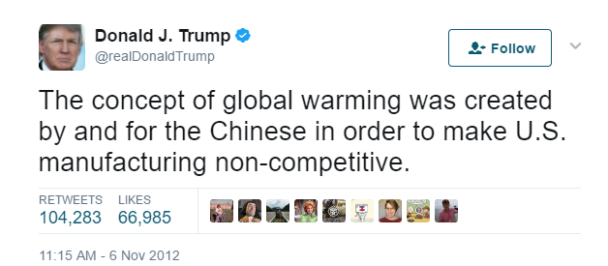

- Jenny McCarthy speaking to Frontline on Jan. 8, 2010:
Obviously, if polio came back with a vengeance, I think the unvaccinated children should get a polio vaccine. But until then, I don’t see the harm in skipping maybe a chicken pox or delaying hepatitis B.

- 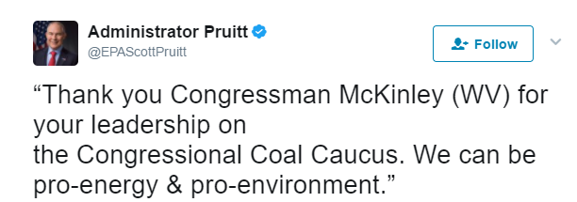

- 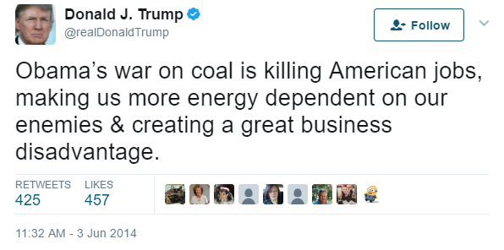

- “Controlling carbon is a bureaucrat's dream.” & *holding snowball* “If it’s unseasonably warm, and global warming is real, how am I holding a snowball? Catch this!” -Sen Jim Inhofe (paraphrased)

- Find one more. Find a quote. By a friend, family member, politician, artist, actor, etc… find one that you can refute with what you’ve learned. Quote both please.

