For the Final, we’ve covered a lot. Focus on these topics and draw diagrams where applicable.
- Circle your least familiar material.
- Meet with a member of the class with the same circles.
- Complete the OTHER sections.
- Meet with a member of the class with different circles
- Aid and complete
Astro Basics
Write each number in scientific notation.
- 0.000006 1b) 5400000
- 60 2b) 0.009
- 6.7 3b) 0.0000002
Metrics. Convert.
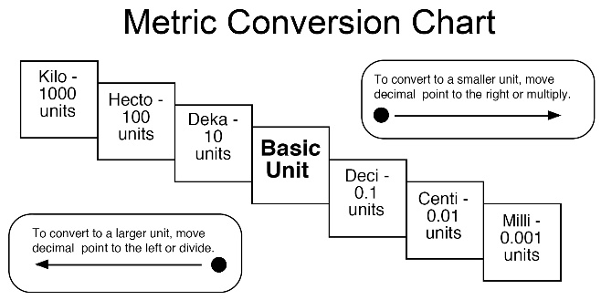

- a. 8 dl = ________ ml b. 800 dal = ________ kl

- a. 8.7 kl = ________ L b. 2 hl = ________ L
Astronomers to know
- What discovery did Aristotle make, and how did he figure this out (long before 1492)?
- What is the most important feature of the Ptolemaic System (developed by Greek astronomer, Ptolemy around 141 A.D.)
- What major change did Copernicus make to the Ptolemaic System about 1300 years later?

- What is an astronomical unit and how many km is it?
- What did Galileo discover about Jupiter, and why was this significant?
- What did he discover about the Sun, and why was this so controversial?
- Tell what “eccentricity” is, and explain why Earth’s orbit around the Sun is not a perfect circle.

- List the following astronomers in order by birth (first to last). Newton, Copernicus, Brahe, Ptolemy, Kepler, Aristotle, and Galileo

Astro 101
- How long is an au? (don’t use km)
- Why is it necessary to use an arcsec as an angle when measuring celestial bodies in our night sky?
- Describe how looking at a star, is like utilizing a time machine…

- What was the mnemonic device you came up with semester 1 to remember the order of the planets?

- What are the major differences between a comet and an asteroid?

- Diagram below the three stages of a meteor.

- Diagram below how we measure a synodic earth day

- Diagram below how we measure a sidereal earth day

Keplar’s Laws
- Explain why the following is REALLY FREAKING FUNNY.
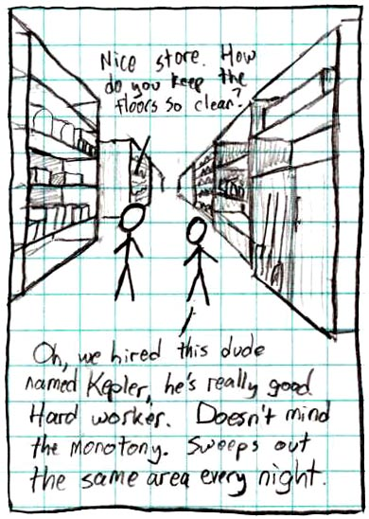
- What is Keplar’s first law? (draw a diagram)

- What is Keplar’s Second law? (draw a diagram)

- What is Keplar’s third law?

- What is the simplified equation that deals with Keplar’s 3rd law?

- If the semi major axis of an orbit of a planet is 2.4AU, what is its period around the star?

- What are the major selling points of both the geocentric and heliocentric models? How do we know which one is right?

- What is the purpose of a leap year?

Light
- The two equations that deal with the frequency of light:

- The Electromagnetic spectrum:
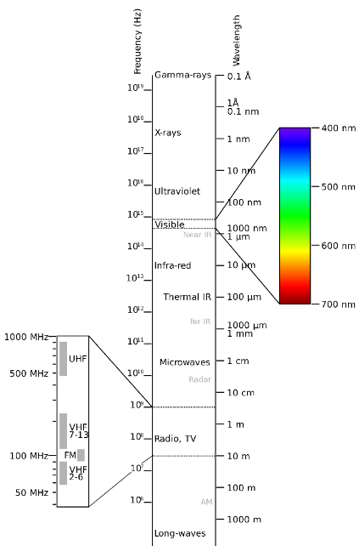and how to arrange the radiations by energy, frequency and wavelength.

- List the Radiations and give a purpose for each

Telescopes
What are the major differences between reflective and refractive telescopes??Might help to draw.

What is an example of a space telescope?

Gravity
- Who came up with the three laws of planetary motion (dealing with orbital shape, width, and correlation to period)?

- In your own words, describe how Newton and Einstein differed in their explanations of what gravity IS. (you may utilize diagrams)

- Below, draw for me a labeled explanation as to how satellites orbit the planet.

- Based on the Law of gravitation, consider the following:
  - I have two masses, one is 10 kg and one is 5 kg. They are placed 10 meters away from each other. The Gravitational force between them is 8N.
    - What would be the value of the force if the masses were made the same as the more massive sample?
    - What would happen to the force if we placed the objects 20 meters apart?
    - What would happen to the force if we placed the objects 2.5 meters apart?
    - What would happen to the force if the masses were set equal to 5kg AND the distance was decreased to 1.25m apart?

- Explain how you currently are enacting force on the Andromeda galaxy

- Attempt to represent the inverse square law for all forces as an equation (hint: involves inverse distance relations)

- What was the Newtonian equation for calculating gravity between two objects?

- You are 70kg. The person sitting next to you is 120kg. You are approx. 1 meter away. What is the force of attraction between you two?

- Describe what would happen if you fell into a tunnel that went through a solid planet, both with and without air resistance. (you may draw a diagram)

- Why do we spaghettify when we enter a black hole? How does this correlate to the tides here on the planet earth?

- What exactly is escape velocity?

The Sun and Stars!
- Below, there are 4 situations in the formation of stars. Draw out the progression of their lives. (it is going to be REALLY HELPFUL to look up the “magic numbers” we talked about concerning solar masses in terms of what they become at the end of their life -white dwarf, black hole, neutron star, etc…-
  - A star with a mass less than .1 M☉

  - A star with a mass of 7 M☉

  - A star with a mass of 10 M☉

  - A star with a mass of 28 M☉

- Label the different areas of the sun in a diagram below

- What is a sunspot? What do we know of how magnetic field lines move between them?

- What kind of sun is our star? Will it go supernova at the end of its lifespan?

- Why is it hotter in the core of our star than on the surface?

- Primarily, what is the major fusion reaction that the sun will do throughout its lifespan? (what elements are involved)

- At the end of its life, as it cools into a dark husk, what will the sun be primarily composed of?

- Why can it sometimes take light energy produced in the core thousands of years to eventually reach us? You may wish to diagram this answer out for your own benefit.

-Types of Stars
9. Stars are all born in molecular clouds present in what astronomical occurance?

10. Describe how dust hundreds of degrees below freezing can eventually become so incredibly hot in the eventual formation of a protostar

11. How does the color of a main sequence star correlate to its temperature?

12. Diagram below how a blue supergiant might look if we sliced it in half and looked at the different areas of fusion (think onion analogy)

-Types of neutron stars
14. How does a neutron star form from a main sequence star? It may be quicker to draw the flow diagram

15. Pulsars are special types of neutron stars. Explain how you can only see their energy if you are in line with their axis.
All notes @ mrdaveyisawesome.yolasite.com
Email me at padavey@cps.edu before Sunday with questions

